

**DEDAN KIMATHI UNIVERSITY OF TECHNOLOGY**

**SCHOOL OF ENGINEERING**

**DEPARTMENT OF MECHATRONICS**

**Designing a 5-Axis CNC system for testing G-Codes of a CNC machine.**

**PRESENTED BY:**

**NAME                                          REG. NO.                            SIGN**

**MAKUMBA OSCAR MOMANYI          E022-01-0730/2017     …………………**

**KELVIN MUGO MURIUKI   E022-01-0725/2017      …………………**

**SIMON MURAYA KIGAMBA        E022-01-0711/2017         ………………....**

**SUPERVISOR: PROF. JEAN BOSCO BYRINGIRO**

# ABSTRACT

A CNC machine is a subtractive machine whose main application is in subtractive manufacturing. It operates under instruction from a script known as G and M codes which is coded by a user and when fed to a CNC machine, the machine can produce a profile desired by the user.

CNC machines are quite expensive and with the rapid increase in demand for interaction with the CNC machine, a need for a convenient way to carry out the CNC operations. With our project one will be able to test line to line execution of G-codes by showing the exact movements required to produce a profile before interacting with the CNC machine. This will help increase accuracy of operation as well as reduce wastage of materials due to errors.

# INTRODUCTION

Computer numerical control machining is a process that enables easier machining of intricate parts aiding in the advancements in the automation industry. Many companies seek CNC machining for their operations so they can follow through on accurate designs and make precise pieces with computer software. However, the cost of a CNC machine is quite high. Take it for example we only had super computers existing and I only need a computer for studying, the cost verses the output is not realistic.

**Objectives**

* To design a CNC machine that can move in 5 axes
* To create a program and circuit to run the system
* To come up with the physical system
* To test G-code on the physical system

# METHODOLOGY

1. **System control flow chart**

A CNC is made up of building block which perform different functions on their own but are all built around the plc. The plc controls the motions of the 5 axis CNC by receiving, processing and outputting the codes dictating the motion to the corresponding block diagram.

The flowchart below shows all the building blocks consisting of our CNC machine.

TIA portal software allows us to program the plc to send signals to stepper motors connected as the outputs of the plc. When configurating the PLC s7-1200 the addresses and version needs to match with the one used for simulations. Project tags are defined and assigned addresses. The program blocks are then defined with functional blocks for every motion.

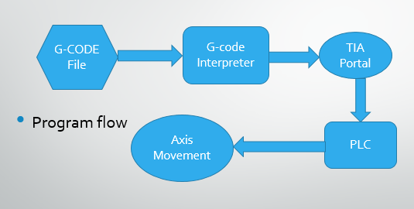

1. **Circuit Analysis**

We developed a TTL circuit that steps down the signal voltage of pulse and directions pins of the PLC from 24v to 5v signal that is required for the better operation of the motor drivers. We designed the circuit using Multisim for simulation purposes and the PCB design was done using Kicad software for fabrication purposes. A total of 10 circuits designs which we are similar were fabricated due to the 10 outputs of the PLC that we required for achieving motion in 5-Axes.

**PCB design of TTL circuit Physically Fabricated PCB**

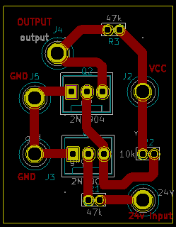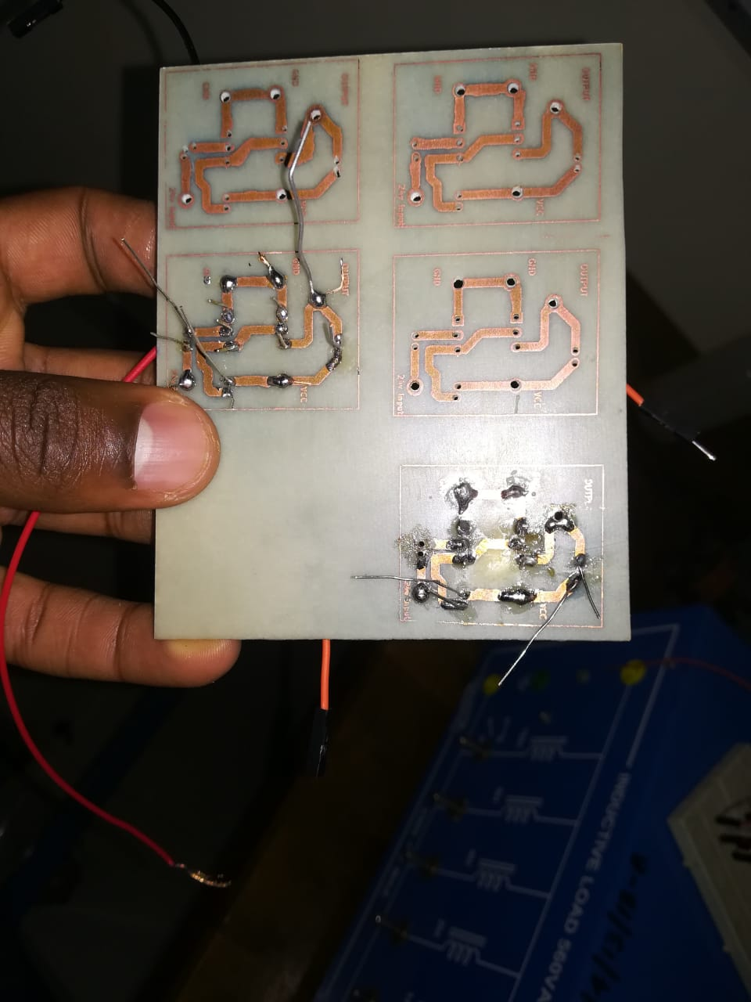

1. **Physical machine**

The initial CAD design of the 5-Axis CNC model was designed using Siemens Nx where all the motions was simulated using Mechatronic Concept Designer in Nx. This formed a guideline in developing the physical machine that can move smoothly in all the 5-axes. The X and Y movements were achieved using timing belts where as the Z movement as achieved using a gear rail that was able to raise up and down the Z-axis. Finally, the rotations A and B were achieved by circular joint interconnection of the moving part to the tool head and the angular movement was achieved as a result. The interconnection between the moving parts and motors was done using araldite adhesive that forms a very strong fixed joint that is not easily separable under normal conditions.

**5-axes physical representation Siemens NX design of 5-Axis CNC**

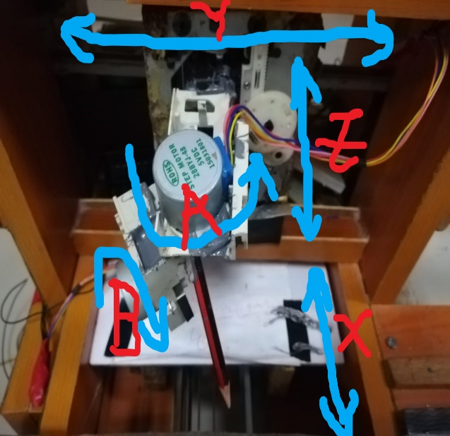 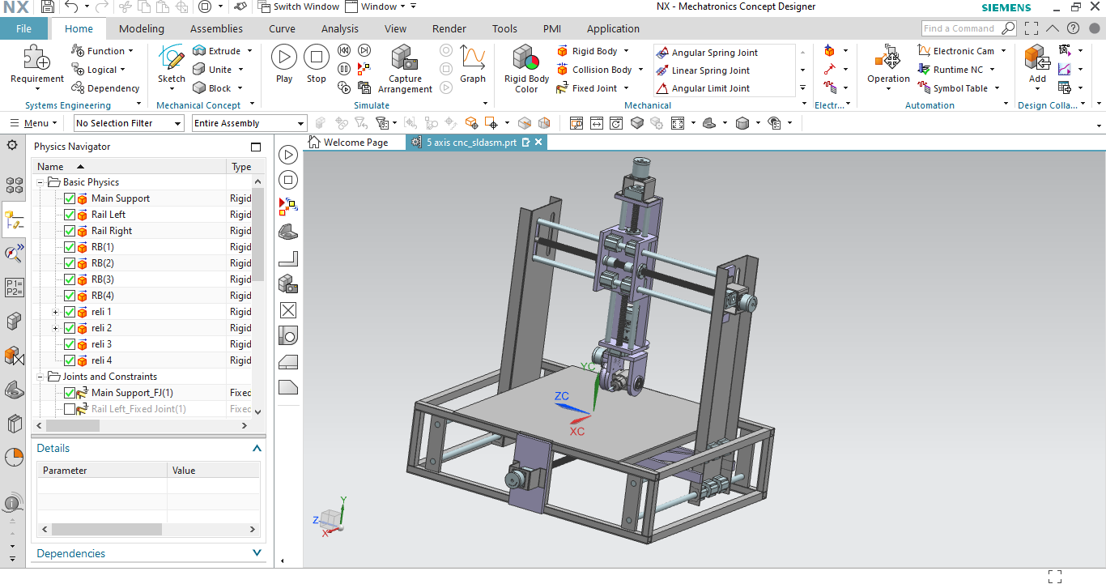

1. **Interpretation of G-CODE**

To run the CNC or test a G Code, the numeric code is written in a file which is then read by a server python script. The client script has libraries imported that enables python communicate with our CNC. The libraries are snap 7 to enable the script interact with the TIA portal and a library, G-code manual has all interpretation for all numeric code instructions.

When the G-code file is read by the script, it is executed line by line and instructions sent to the specific PLC tags via a client python script that writes data to the PLC which then causes motion in the CNC physical model.

Technological axes X, Y, Z, A and B defined when one axis is enabled in the TIA portal ladder program where the movement function of each axis when enabled via the G-code script changes the values of the axis initial position from Low level to the final value input.

# RESULTS ANALYSIS

1. **Technological axes for Rotation A**

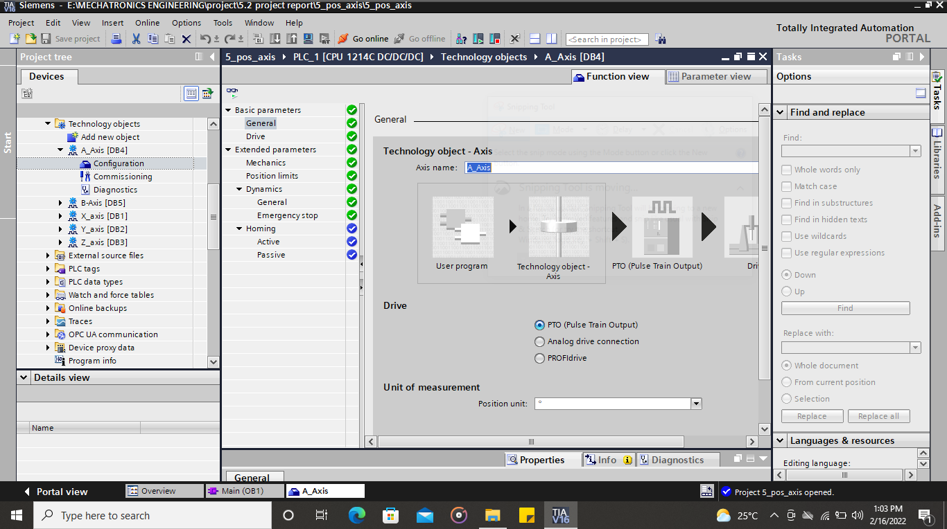

1. **Displacement of Rotation A at initial position**

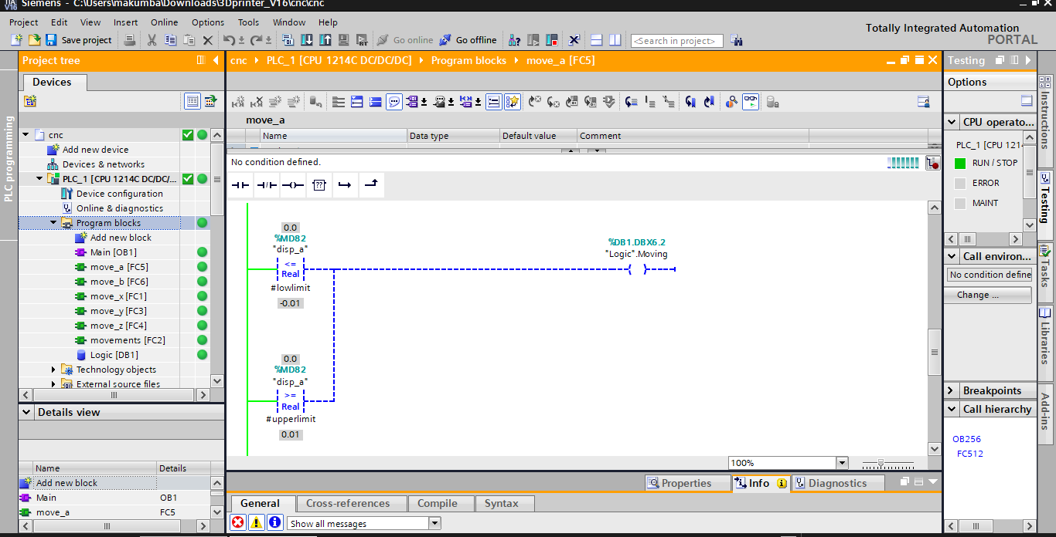

1. **Displacement of Rotation A at final position of 10 degrees**

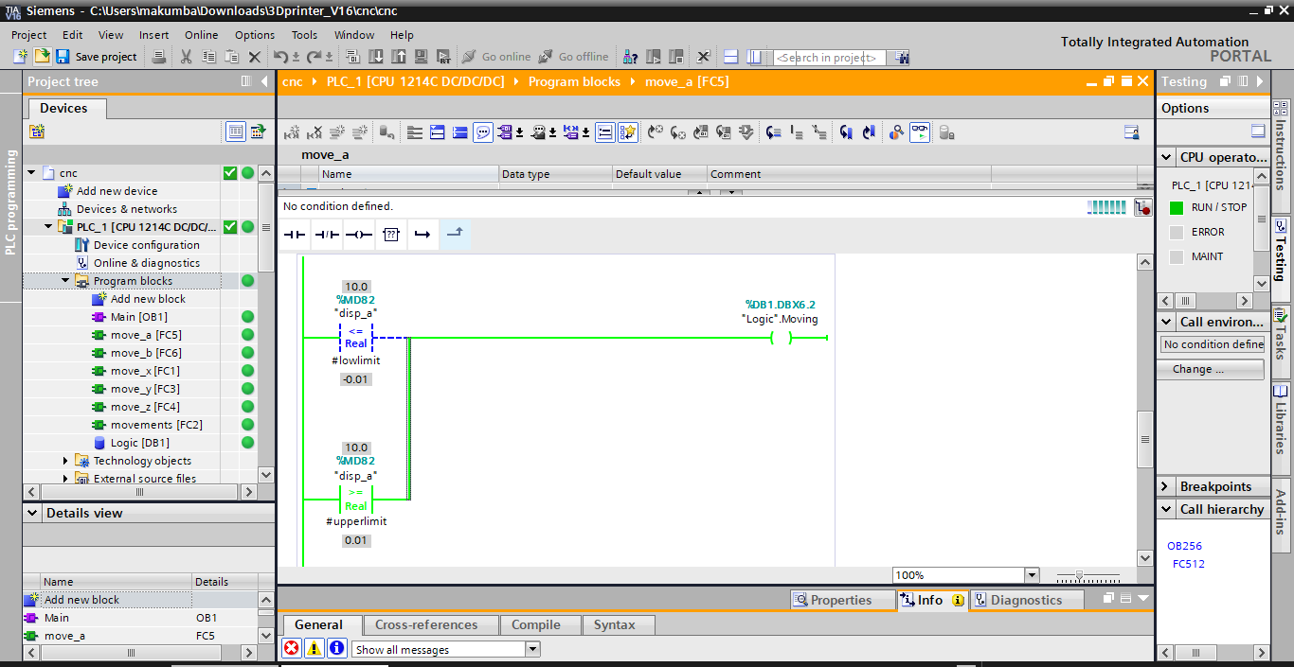

# DISCUSSION

**Positioning axis technology object**  
The physical drive including mechanics is mapped in TIA Portal as a positioning axis  
technology object. To do this, configure the positioning axis technology object with the  
following parameters:  
● Selection of the PTOs (Pulse Train Output)/PROFIdrive drives/analog outputs to be used  
and configuration of the drive interface  
● Parameter for mechanics and gear transmission of the drive (or the machine or system)  
● Parameters for position limits and position monitoring  
● Parameters for dynamics and homing  
● Parameters for the control loop  
The configuration of the positioning axis technology object is saved in the technology object  
(data block). This data block also forms the interface between the user program and the  
CPU firmware. The current axis data is saved in the data block of the technology object at  
the runtime of the user program

You start Motion Control instructions jobs in the CPU firmware with the user program. The  
following jobs for controlling the axis are possible:  
● Enable and disable axis ● Position axis absolutely ● Position axis relatively ● Move axis with velocity set point ● Run axis commands as movement sequence (technology as of V2, PTO only)  
● Moving axes in jog mode ● Stop axis ● Reference axis; set reference point ● Change dynamic settings of axis ● Continuously read motion data of the axis ● Read and write variable of the axis  
● Acknowledge error

# CONCLUSION

In conclusion, we were able to develop the structure of the 5 axis CNC machine where it was able to demonstrate the motions and interpret the G-code fed to it. The physical structure was a simple model just to demonstrate the working principle. The concept was to write a G-code interpreter code and design a circuit that fulfills the objectives. This was realized as seen in the results.

# REFERENCES

1. Paulo Augusto Sherring da Rocha Junior, Rogério Diogne de Silva e Souza, Maria Emília de Lima Tostes. (2010, November). *Prototype CNC machine design.* Retrieved from

<https://www.researchgate.net/publication/241180827_Prototype_CNC_machine_design>

1. Wang Feng, Lin Hu, Zheng Liaomo, Yang Lei, Feng Jinjin, Zhang Han. (2014, February). *Design and implementation of five-axis transformation function in CNC system.* Retrieved from <https://www.sciencedirect.com/journal/chinese-journal-of-aeronautics>
2. Mariana Ratiu. (2016, August). *Short literature review on the optimization of the five-axis CNC machines.* Retrieved from <https://pdfs.semanticscholar.org/e5c7/70ad91efd74c6c19149c2d9045fd1c4285d5.pdf>
3. SIMATIC STEP 7 S7-1200 Motion Control V6.0 to V7.0 in TIA Portal V16 function manual.
4. <https://automationtop.com/control-of-the-stepping-motor-by-using-s7-1200-configuration-of-the-motion-control/>
5. <https://support.industry.siemens.com/cs/attachments/109754206/s71200_motion_control_function_manual_en-US_en-US.pdf>